**TONGAN TRANSLATION**

**https://24x7offshoring.com/**

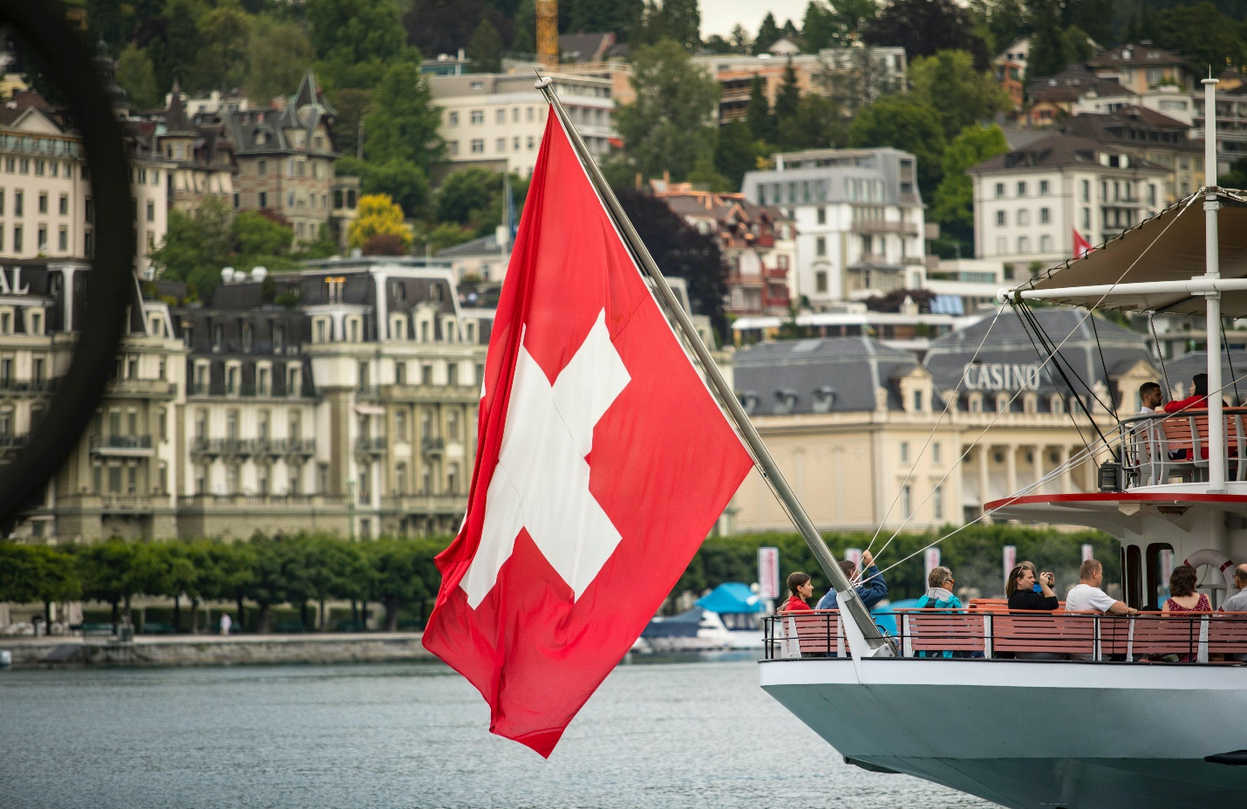 [**http://24x7outsourcing.com/**](http://24x7outsourcing.com/)

**Tongan Language Translation**

**Presentation of the Kingdom of Tonga**

The Kingdom of Tonga, otherwise called the Friendly Islands, is an individual from the British Commonwealth. It is situated in the South Pacific Ocean, toward the west of the International Date Line.

There are an aggregate of 176 islands, 36 of which are populated. With a tropical blustery environment, the dry season is from May to August, and the stormy season is from December to April.

It has a populace of around 100,000 (2005), 98% of them are local, and others are European, Asian and some pacific island man. Nuku'alofa is the capital, with 60,000 individuals (2005).

**Presentation of Tongan**

Tongan is a sort of west Polynesian language. It's one of the two authority dialects of the Kingdom of Tonga (the other authority language is English). The locals for the most part utilize Tongan, while residents and government authorities like to utilize English.

It is fundamentally the same as the dialects of Samoan just as Niue and Uvea (Wallis).

Other than the Kingdom of Toga, Tongan is additionally utilized in Eastern Samoa, Australia, Canada, New Zealand, USA and Vanuatu.

**Tongan Alphabet**

There are 17 letters in the Tongan letters in order, five vowels and eleven consonants and the glottal stop: a, e, f, h, I, k, l, m, n, ng, o, p, s, t, u, v, '.

**A few models are as per the following:**

A, sounds as in father (a);

H, sounds as in cap (ha);

N G n g, sounds as in artist (nga);

U, sounds as in root (u);

…

The last one ' is the glottal stop (fakau'a).

These vowels can be extended: the multiplied span vowels are composed with a macron over them: ā, ē, ī, ō, ū.

**Some Useful Expressions**

**English Tongan**

Hi Mālō e lelei

How are you? Fēfē hake?

Fine Sai

Much obliged to you Mālō

Much thanks Mālō 'aupito

Pardon me Tulou

Sorry Fakamolemole

Obviously. Ka ko toe hā

What is your name? Ko hai ho hingoā?

My name is… Ko hoku hingoā ko…

Great morning Mālō 'etau magma ki he pongipongī ni

Great evening Mālō 'etau magma ki he efiafī ni

Great night Mālō 'etau magma ki he poō ni

**Tongan Translation with One-stop administrations**

All Tongan interpreters at 24X7OFFSHORING.CCOM are qualified interpreters. They are aces in language, yet additionally had some expertise in their own fields, like law, account, mechanical, hardware and science. As we as a whole know, the degree of unknown dialect interpreters in various types of social associations continue to rise.

The justification 24X7OFFSHORING.CCOM's prosperity is on the grounds that our interpretation administration is centered on particular materials. At times our customers absence of sufficient opportunity and assets; here and there they absence of interpreters in specific fields.

Our organization has numerous phenomenal interpreters and editors for countless dialects in pretty much every field.

**For each work, we go through a severe TEP measure:**

Translation-Edition-Proofreading.

**We have Tongan interpreters to cover different fields including however not restricted to:**

Tongan Marketing interpretations

Tongan Medical interpretations

Tongan IT interpretations

Tongan interpretations for specialized manuals and handouts

Tongan interpretations for the movement business

Tongan interpretations for mechanical designing

**TONGAN TRANSLATION**

**https://24x7offshoring.com/**

**http://24x7outsourcing.com/**